**VISVESVARAYA TECHNOLOGICAL UNIVERSITY**

Jnana Sangama, Belgaum-590018



A DBMS MINI-PROJECT REPORT

ON

**“CAR WASH MANAGEMENT SYSTEM”**

Submitted in partial fulfilment of the requirements for the award of the degree of

**BACHELOR OF ENGINEERING**

**IN**

**COMPUTER SCIENCE AND ENGINEERING**

Submitted by

SANYAM SHARMA 1KI20CS087

VARSHA T S 1KI20CS123

**Under the Guidance of**

Dr. Chethan Chandra S Basavaraddi B.E,M.Tech,Ph.D

Associate Professor



DEPARTMENT OF COMPUTER SCIENCE AND ENGINEERING

**KALPATARU INSTITUTE OF TECHNOLOGY**

TIPTUR-572201

2022-2023

**KALPATARU INSTITUTE OF TECHNOLOGY**

TIPTUR-572201

**Department of Computer Science and Engineering**



**CERTIFICATE**

Certified that the DBMS mini-project work entitled **“CAR WASH MANAGEM”** is a bonafide workcarried out by

**SANYAM SHARMA** 1KI20CS087

**VARSHA T S** 1KI20CS123

in partial fulfilment for the award of **Bachelor of Engineering** in **Computer Science and Engineering** of the **Visvesvaraya Technological University, Belgaum** during the year 2022-2023. It is certified that all corrections/suggestions indicated for Internal Assessment have been incorporated in the report deposited in the departmental library. The mini-project report has been approved as it satisfies the academic requirements in respect of mini-project work prescribed for the said Degree.

**Dr. Chethan Chandra S Prof. Niranjan S J Prof. Shashidhara M S**

**Basavaraddi**

Guide Mini-Project Coordinator Head of Department

**Dr. G. D. Gurumurthy,M.Tech., Ph.D**

Principal

**External Viva**

Name of Examiners Signature with date

1.

2.

**KALPATARU INSTITUTE OF TECHNOLOGY**

TIPTUR-572201

**Department of Computer Science and Engineering**



**DECLARATION**

We, the students of fifth semester of Computer Science and Engineering , Kalpataru Institute of Technology Tiptur-572201, declare that the work entitled  **“CAR WASH MANAGEMENT SYSTEM”** has been successfully completed under the guidance of (Guide name), Department of Computer Science and Engineering. This DBMS mini-project report work is submitted to Visvesvaraya Technological University in partial fulfilment of the requirements for the award of Degree of Bachelor of Engineering in *Computer Science and Engineering* during the academic year 2022 - 2023. Further the matter embodied in the mini-project report has not been submitted previously by anybody for the award of any degree or diploma to any university.

Place: Tiptur

Date: dd/mm/yyyy

Project Associates:

1. **SANYAM SHARMA**

2. **VARSHA T S**

**ABSTRACT**

The Project “Car Washing Management System” Project is a web application.

In-Car Washing Management System Project in PHP performed all the operations needed to clean the car successfully by using highly expert and experienced workers, also developed mimic of the whole system, works and checked the overall process step by step by visualization

INDEX

Page No

1**.Acknowledgement 6**

2.**Project Overview 7**

* Proposed system

3**.Feasibility Report 9**

* Technical Feasibility
* Operation Feasibility
* Economic Feasibility

4**.System Analysis 11**

* Admin
* User

5**.Requirment Specification 13**

* Hardware Configuration
* Software requirement
* Apache
* MYSQL

**6.System Design 16**

* Introduction to UML
* Entity Relationship Diagram

**7.Database Implementation 21**

* Database Tables
* Class Diagrams/Schema

**8.Output Screen of Project 24**

**9.Conclusion 37**

**10.Biblography 38**

**1.ACKNOWLEDGEMENT**

I am are over helmed in all humbleness and gratefulness to acknowledge my depth to all those who have helped me to put these ideas, well above the level of simplicity and into something concrete.

I would like to express my special thanks of gratitude to my esteemed guide, Dr. Chethan Chandra Basavaraddi sir, who gave me the golden opportunity to do this wonderful project which also helped me in doing a lot of Research and I came to know about so many new things. I am really thankful to them.  
Any attempt at any level can 't be satisfactorily completed without the support and guidance of MY parents and friends.

I would like to thank my parents who helped me a lot in gathering different information, collecting data and guiding me from time to time in making this project, despite of their busy schedules , they gave me different ideas in making this project unique.

.

**----------------------**

**2. Project Overview**

We aim to become a pioneer in the car washing industry by completely focusing on customers, our employees, growth, innovation and efficiency. All of these elements will drive us towards success and show us as one company that can perform and give value for money.

When it comes car washing services, Cool Service is the most trusted and reliable name in the car washing business. This system uses large quantity of water, thus water recycling plant is also an integral part of the car washing system but at this level we are only presented the car washing only. And this project continually strive to offer the best of services - both in terms of man and machine, to our clients  
Moreover, car washing system is fully automated with different stages of foaming, washing, drying and brushing. And this project claim to offer the best of rates, which are tailor-made depending upon the facilities, availed and offer both intercity and intra-city car washing facilities. In Car Washing System, we performed all the operations needed to clean the car successfully by using higly expert and experience worker, also developed mimic of the whole system and works and checked the overall process step by step by visualization. Car washing workers are educated, polite, and reliable and are trained to handle acute breakdowns. Further, this project’s utmost priority is quality. A car wash is a service that cleans both the outside and the inside of a vehicle. Self-serve car washes, fully automated car washes, and full-service car washes with employees are all available options. It simplifies automotive cleaning and washing. Blowers or dryers, brushes, conveyor/tunnel carwash equipment, air compressors, applicator pump stations, conveyors, high-pressure equipment, pump stands/racks, and other things are utilized for car washing. Shampooing, rinsing, washing, and drying are all automated steps of the car wash.

Car Washing Management System is fully automated with different stages of foaming, washing, drying and brushing. In Car Washing System, we performed all the operations needed to clean the car successfully by using highly expert and experience worker, also developed mimic of the whole system and works and checked the overall process step by step by visualization. Authorized person maintains the car washing details in papers, which is a tedious task if any updating or changes need to be done.

* Details are stored in Papers.
* Maintenance is a huge problem.
* Updation, changes in details is a tedious task.
* Performance is not achieved up to the requirements.

**Proposed System**

In the Previous System, Details are Stored Manually in papers, to share the details between employees was a financial drawback. Updating in the details is a tedious task.

But a new system was proposed to overcome the above drawbacks.

Functionalities and advantages of proposed system are:

* Data is Centralized which has overcome the Sharing problem in previous system.
* As data is Maintained electronically, it’s easy for a person to update the details, which has overcome the tedious updation in previous system.
* Maintenance is easy and performance is good.
* Mainly the system has automated the Transportation Process.

**3. Feasibility Report**

Preliminary investigation examine project feasibility, the likelihood the system will be useful to the organization. The main objective of the feasibility study is to test the Technical, Operational and Economical feasibility for adding new modules and debugging old running system. All system is feasible if they are unlimited resources and infinite time. There are aspects in the feasibility study portion of the preliminary investigation:

* Technical Feasibility
* Operation Feasibility
* Economical Feasibility

**3.1. Technical Feasibility**

The technical issue usually raised during the feasibility stage of the investigation includes the following:

* Does the necessary technology exist to do what is suggested?
* Do the proposed equipments have the technical capacity to hold the data required to use the new system?
* Will the proposed system provide adequate response to inquiries, regardless of the number or location of users?
* Can the system be upgraded if developed?
* Are there technical guarantees of accuracy, reliability, ease of access and data security?

Earlier no system existed to cater to the needs of ‘Secure Infrastructure Implementation System’. The current system developed is technically feasible. It is a web based user interface for audit workflow . Thus it provides an easy access to the users. The database’s purpose is to create, establish and maintain a workflow among various entities in order to facilitate all concerned users in their various capacities or roles. Permission to the users would be granted based on the roles specified.

**3.2. Operational Feasibility**

Proposed projects are beneficial only if they can be turned out into information system. That will meet the organization’s operating requirements. Operational feasibility aspects of the project are to be taken as an important part of the project implementation. Some of the important issues raised are to test the operational feasibility of a project includes the following: -

* Is there sufficient support for the management from the users?
* Will the system be used and work properly if it is being developed and implemented?
* Will there be any resistance from the user that will undermine the possible application benefits?

This system is targeted to be in accordance with the above-mentioned issues. Beforehand, the management issues and user requirements have been taken into consideration. So there is no question of resistance from the users that can undermine the possible application benefits.

**3.3. Economic Feasibility**

A system can be developed technically and that will be used if installed must still be a good investment for the organization. In the economical feasibility, the development cost in creating the system is evaluated against the ultimate benefit derived from the new systems. Financial benefits must equal or exceed the costs.

**4. System Analysis**

**Overview**

We aim to become a pioneer in the car washing industry by completely focusing on customers, our employees, growth, innovation and efficiency. All of these elements will drive us towards success and show us as one company that can perform and give value for money. This Service will make A manager to think of whether the transportation is expensive and maintaining quality or not.

In Car Washing Management System, we performed all the operations needed to clean the car successfully by using highly expert and experience worker, also developed mimic of the whole system, works and checked the overall process step by step by visualization.

. In this project, we use PHP and MySQL database. It has two modules.

1. Admin
2. Users

**Admin**

1. **Dashboard:** In this section, admin can see two wheeler and four wheeler vehicle detail in brief.
2. **Washing Points:** In this section, admin can manage washing location (Add/Update).
3. **Add Car Washing Booking:** In this section, admin add car washing booking on his/her end.
4. **Car Washing Booking:** In this section, admin can view booking details of car washing which is booked by users.
5. **Manage Enquiries:** In this section, admin can read the enquiries of users.
6. **Pages:**In this section, the admin can manage about us and contact us pages.

**Admin can also change the password of his/her account.**

**Users**

1. **Home Page:** Users can see the listed vehicles on the home page.
2. **About Us:** Users can view about us page.
3. **Washing plans**: User can view car washing plans and book that plans.
4. **Washing points**: User can view car washing location.
5. **Contact us:** Users can view the contact us page and do eqnuiry.

**5. Requirement Specification**

**Hardware Configuration :**

**Client Side:**

|  |  |
| --- | --- |
| **RAM RAMfgdf RAM** | 512 MB |
| **Hard disk** | 10 GB |
| **Processor** | 1.0 GHz |

**Server side:**

|  |  |
| --- | --- |
| **RAM** | **1 GB** |
| **Hard disk** | **20 GB** |
| **Processor** | **2.0 GHz** |

**Software Requirement:**

**Client Side:**

|  |  |
| --- | --- |
| **Web Browser** | Google Chrome or any compatible browser |
| **Operating System** | Windows or any equivalent OS |

**Server Side:**

|  |  |
| --- | --- |
| **Web Server** | APACHE |
| **Server side Language** | PHP5.6 or above version |
| **Database Server** | MYSQL |
| **Web Browser** | Google Chrome or any compatible browser |
| **Operating System** | Windows or any equivalent OS |

**APACHE**

The Apache HTTP Server Project is an effort to develop and maintain an open-source HTTP server for modern operating systems including UNIX and Windows. The goal of this project is to provide a secure, efficient and extensible server that provides HTTP services in sync with the current HTTP standards.

The Apache HTTP Server ("http") was launched in 1995 and it has been the most popular web server on the Internet since April 1996. It has celebrated its 20th birthday as a project in February 2015.

**PHP**

* PHP stands for PHP: Hypertext Preprocessor.
* PHP is a server-side scripting language, like ASP.
* PHP scripts are executed on the server.
* PHP supports many databases (MYSQL, Informix, Oracle, Sybase, Solid, Generic ODBC, etc.).
* PHP is open source software.
* PHP is free to download and use.

**MYSQL**

* MYSQL is a database server
* MYSQL is ideal for both small and large applications
* MYSQL supports standard SQL
* MYSQL compiles on a number of platforms
* MYSQL is free to download and use
* How to access MySQL: <http://localhost/phpmyadmin>

**6. System Design**

**Unified Modeling Language Diagrams (UML):**

* + The unified modeling language allows the software engineer to express an analysis model using the modeling notation that is governed by a set of syntactic semantic and pragmatic rules.
  + A UML system is represented using five different views that describe the system from distinctly different perspective. Each view is defined by a set of diagram, which is as follows.

**User Model View**

* + 1. This view represents the system from the users perspective.
    2. The analysis representation describes a usage scenario from the end-users perspective**.**

**Structural model view**

◆In this model the data and functionality are arrived from inside the system.

◆ This model view models the static structures.

**Behavioral Model View**

◆ It represents the dynamic of behavioral as parts of the system, depicting the interactions of collection between various structural elements described in the user model and structural model view.

**Implementation Model View**

* + In this the structural and behavioral as parts of the system are represented as they are to be built.

**Environmental Model View**

In this the structural and behavioral aspects of the environment in which the system is to be implemented are represented.

UML is specifically constructed through two different domains they are

* + UML Analysis modeling, which focuses on the user model and structural model views of the system?
  + UML design modeling, which focuses on the behavioral modeling, implementation modeling and environmental model views**.**

**Use Case flow Diagram (User)**

**Use Case flow Diagram (Admin)**

#### ENTITY-RELATIONSHIP Diagrams

#### 

E-R (Entity-Relationship) Diagram is used to represents the relationship between entities in the table.

The symbols used in E-R diagrams are:

SYMBOL PURPOSE

Represents Entity sets.

Represent attributes.

Represent Relationship Sets.

Line represents flow

Structured analysis is a set of tools and techniques that the analyst.

To develop a new kind of a system:

The traditional approach focuses on the cost benefit and feasibility analysis, Project management, and hardware and software selection a personal considerations.

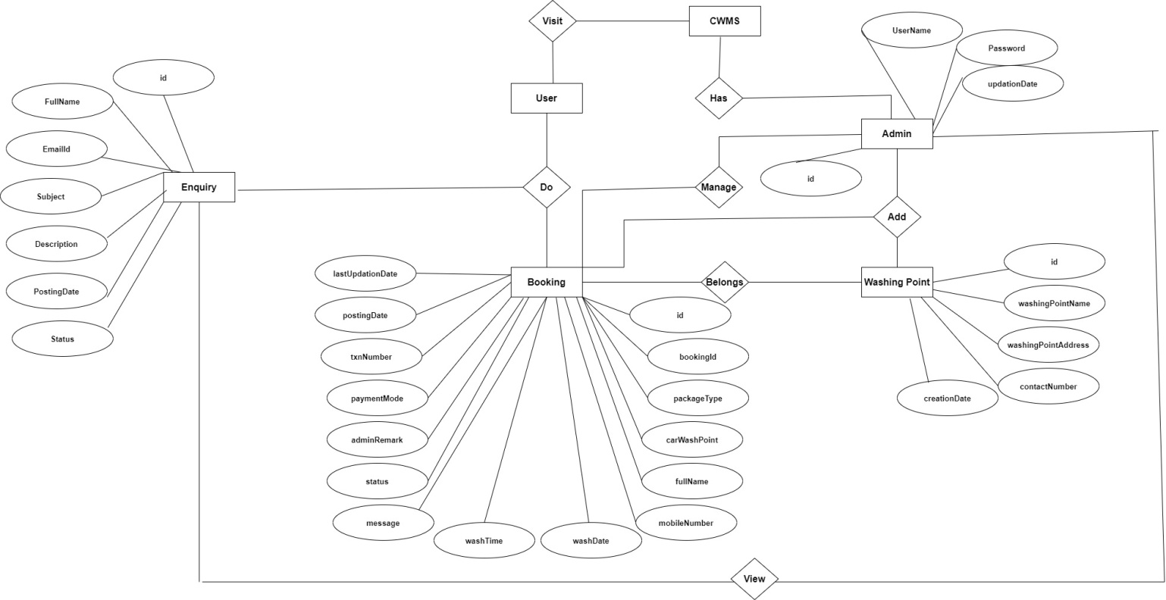

**7. Database Implementation**

MYSQL- MySQL ("My S-Q-L", officially, but also called "My Sequel") is (as of July 2013) the world's second most widely used open-source relational database management system (RDBMS). It is named after co-founder Michael Widenius daughter, My. The SQL phrase stands for Structured Query Language. The MySQL development project has made its source code available under the terms of the GNU General Public License, as well as under a variety of proprietary agreements. MySQL was owned and sponsored by a single for-profit firm, the Swedish company MySQL AB, now owned by Oracle Corporation .MySQL is a popular choice of database for use in web applications, and is a central component of the widely used LAMP opens source web application software stack (and other 'AMP' stacks). LAMP is an acronym for "Linux, Apache, MySQL, Perl/PHP/Python." Free-software-open source projects that require a full-featured database management system often use MySQL. For commercial use, several paid editions are available, and offer additional functionality. Applications which use MySQL databases Library Management System include: TYPO3, MODx, Joomla, WordPress, phpBB, MyBB, Drupal and other software. MySQL is also used in many high-profile, large-scale websites, including Wikipedia, Google (though not for searches), Facebook, Twitter, Flickr, and YouTube.

**Database tables**

In this project various tables used for maintain the information.

[**admin**](http://localhost/phpmyadmin/sql.php?db=camsdb&token=0cdfa1f46252d35aec9fa851dd4c03bb&goto=db_structure.php&table=tbladmin&pos=0) **:** This table use to store admin login details.

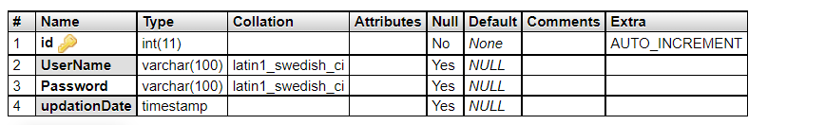

**tblenquiry:** This table store the enquiry details of users..

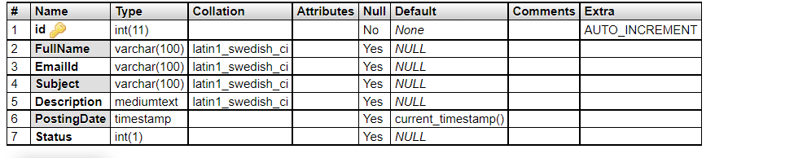

**tblwashingpoints:** This table use to store location of car washing.

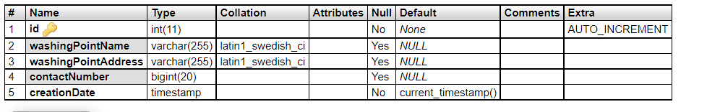

**tblcarwashbooking:** This table use to car washing booking details.

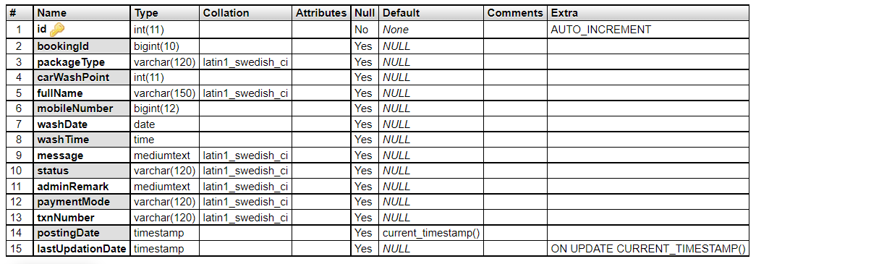

**tblpage:** This table use to store pages info details.

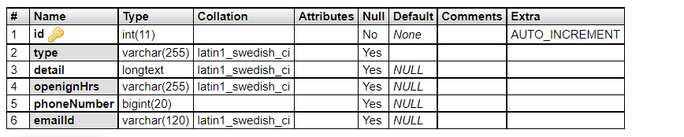

**Class Diagram / Schema:**

The class diagram shows a set of classes, interfaces, collaborations and their relationships.

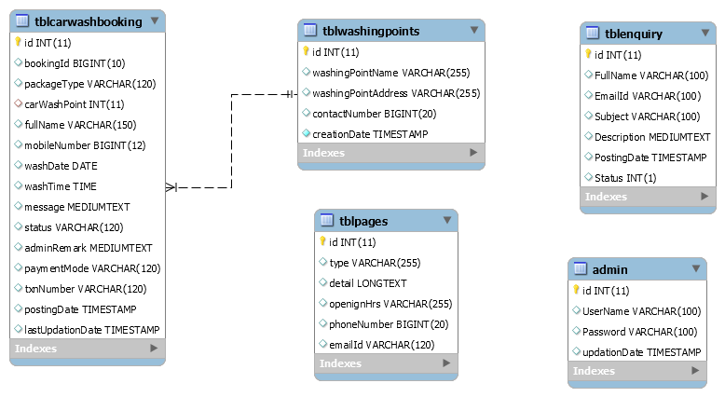

**8. Output Screen of Project**

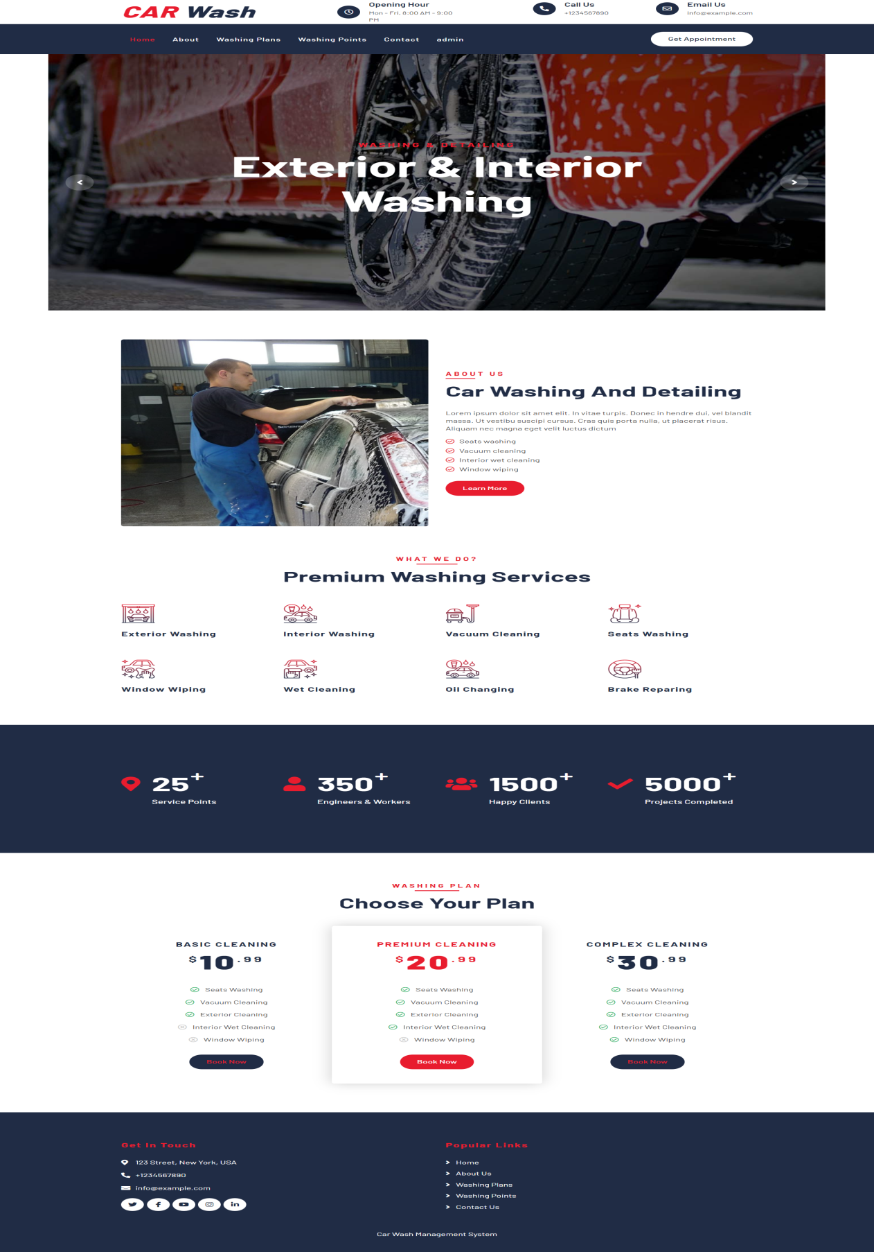

**About Us**

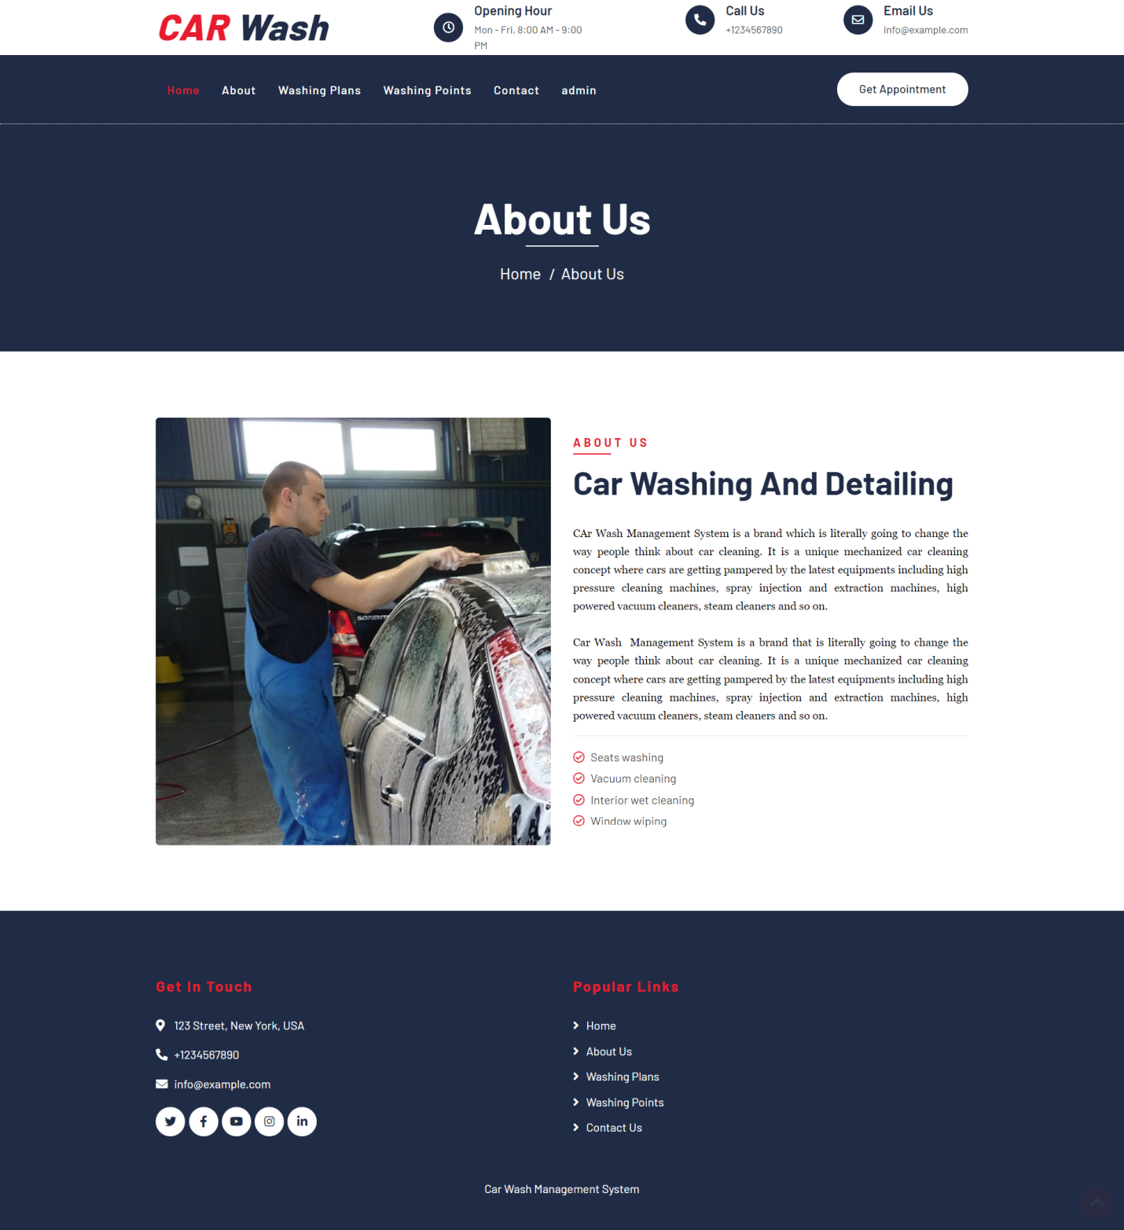

**Washing Points(Locations)**

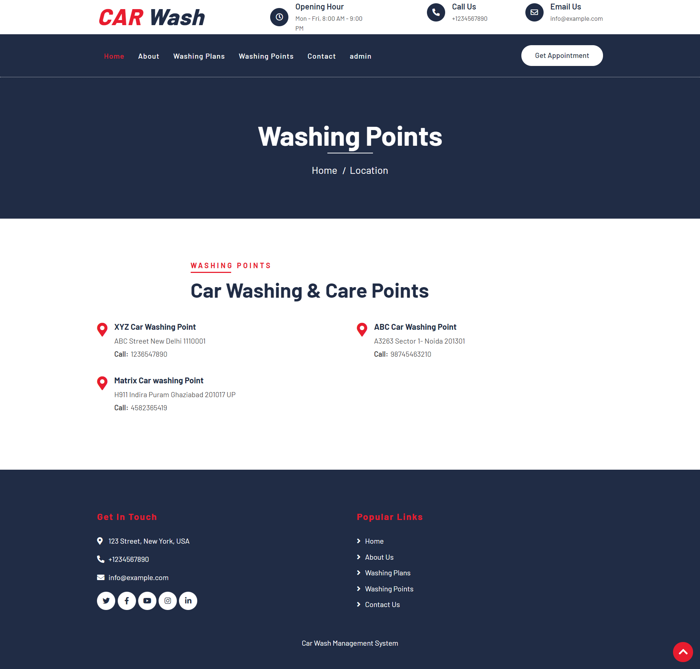

**Washing Plans**

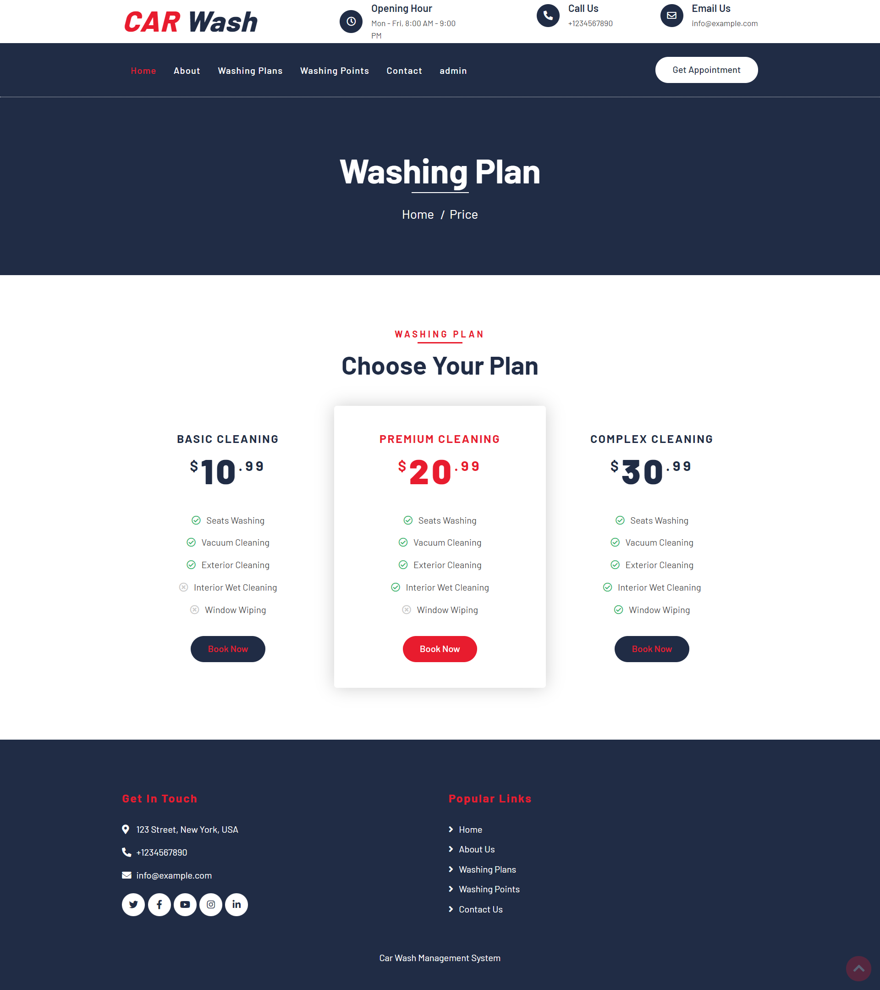

**Contact Us**

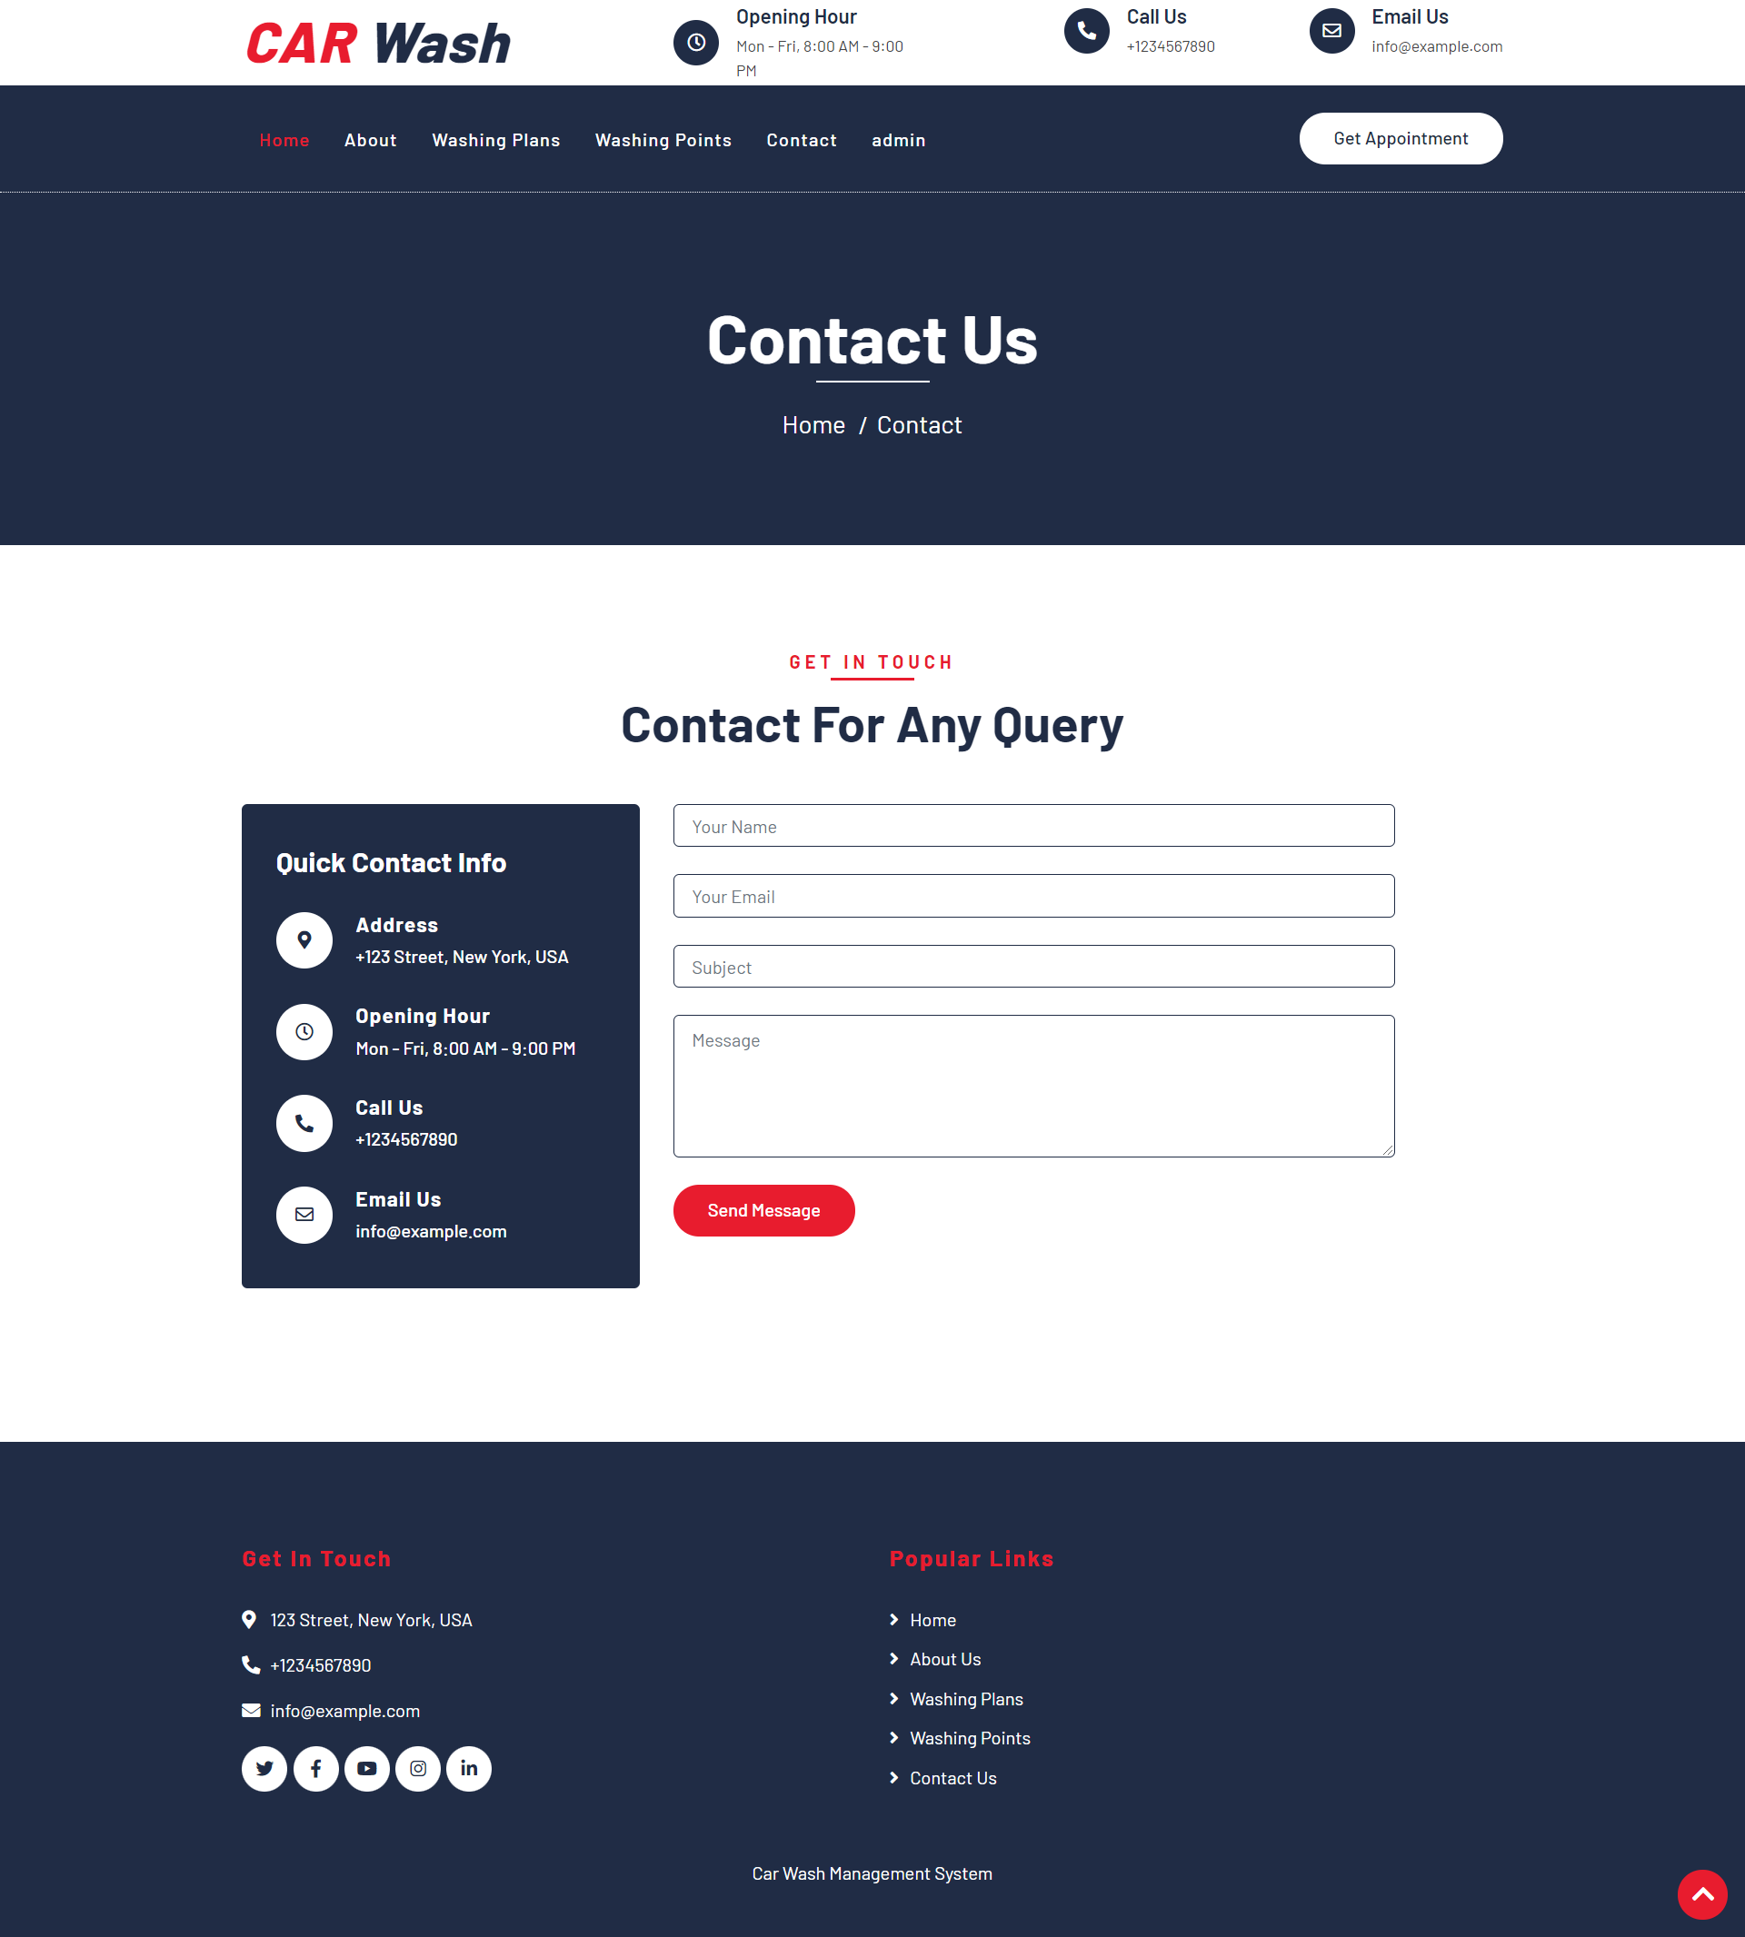

**Booking**

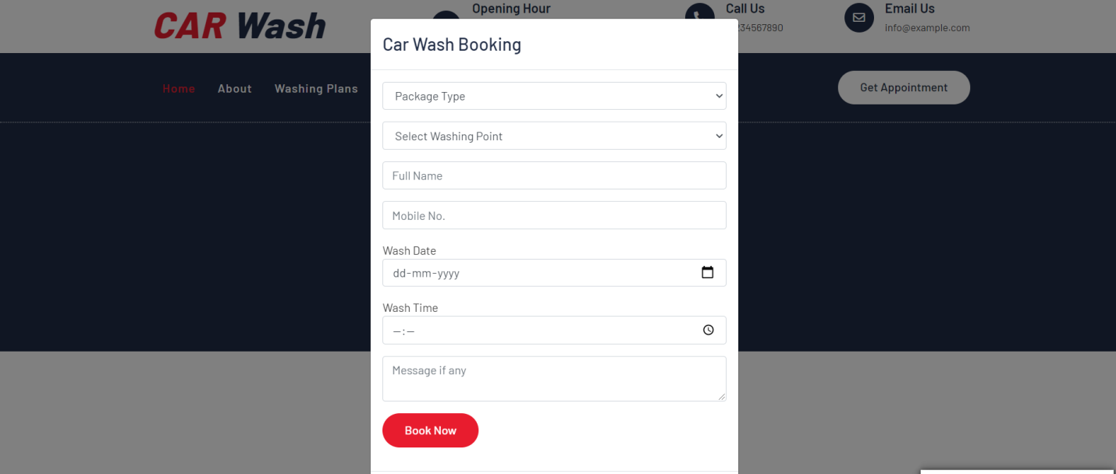

**Admin Login Page**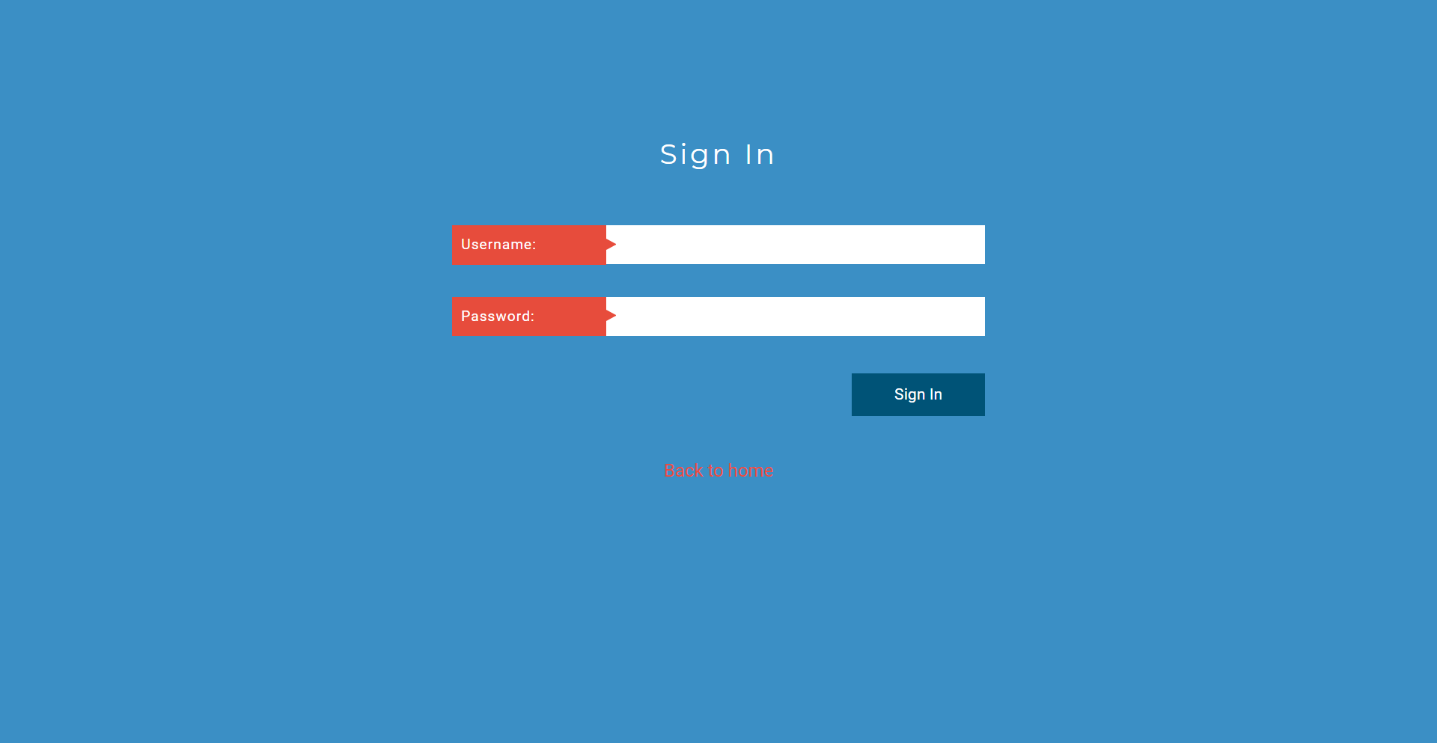

**Dashboard**

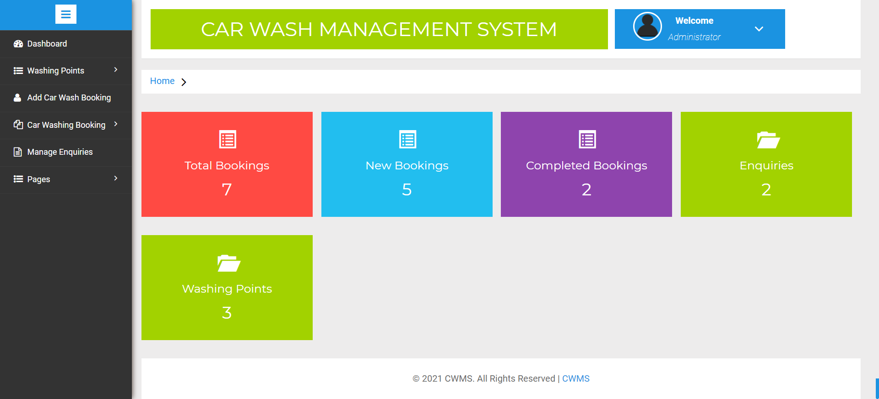

**Change Password**

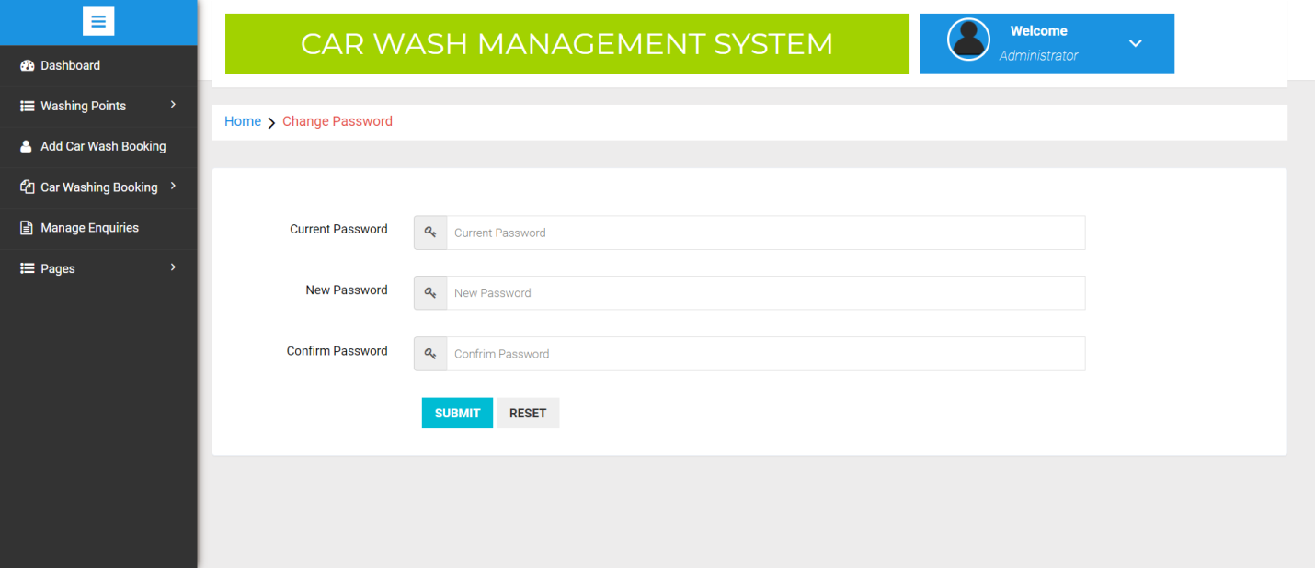

**Add Washing Points**

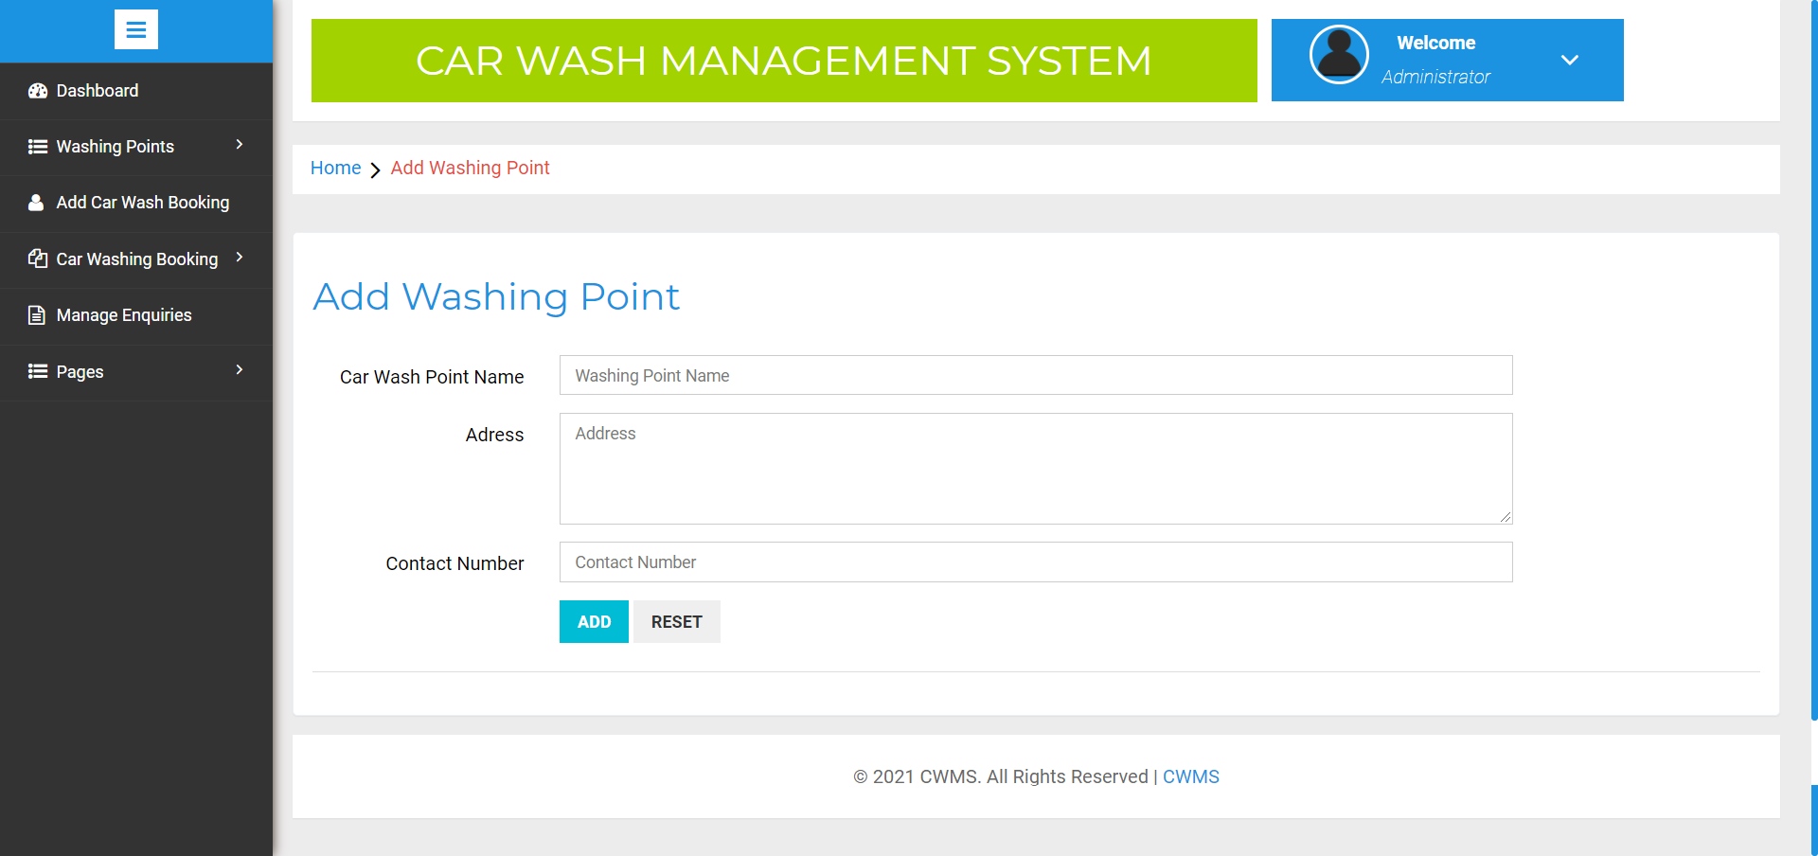

**Manage Washing Points**

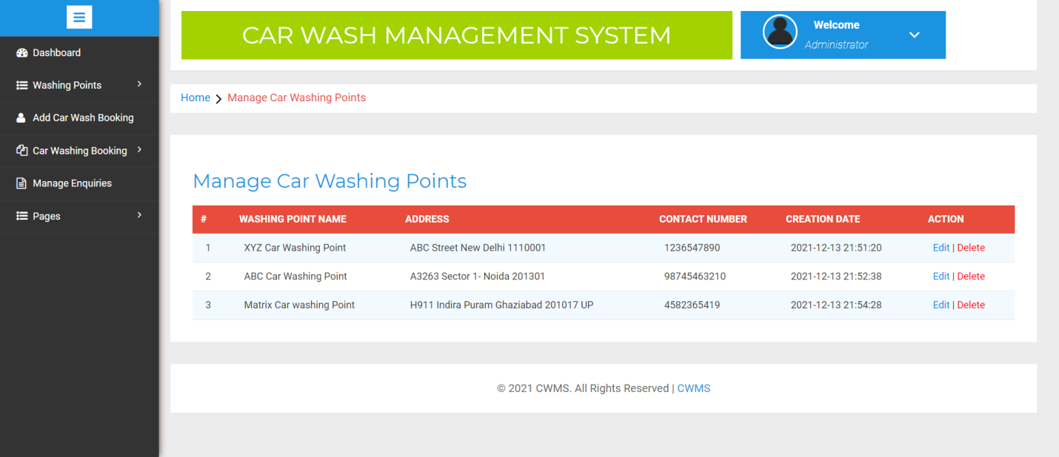

**Update Washing Points**

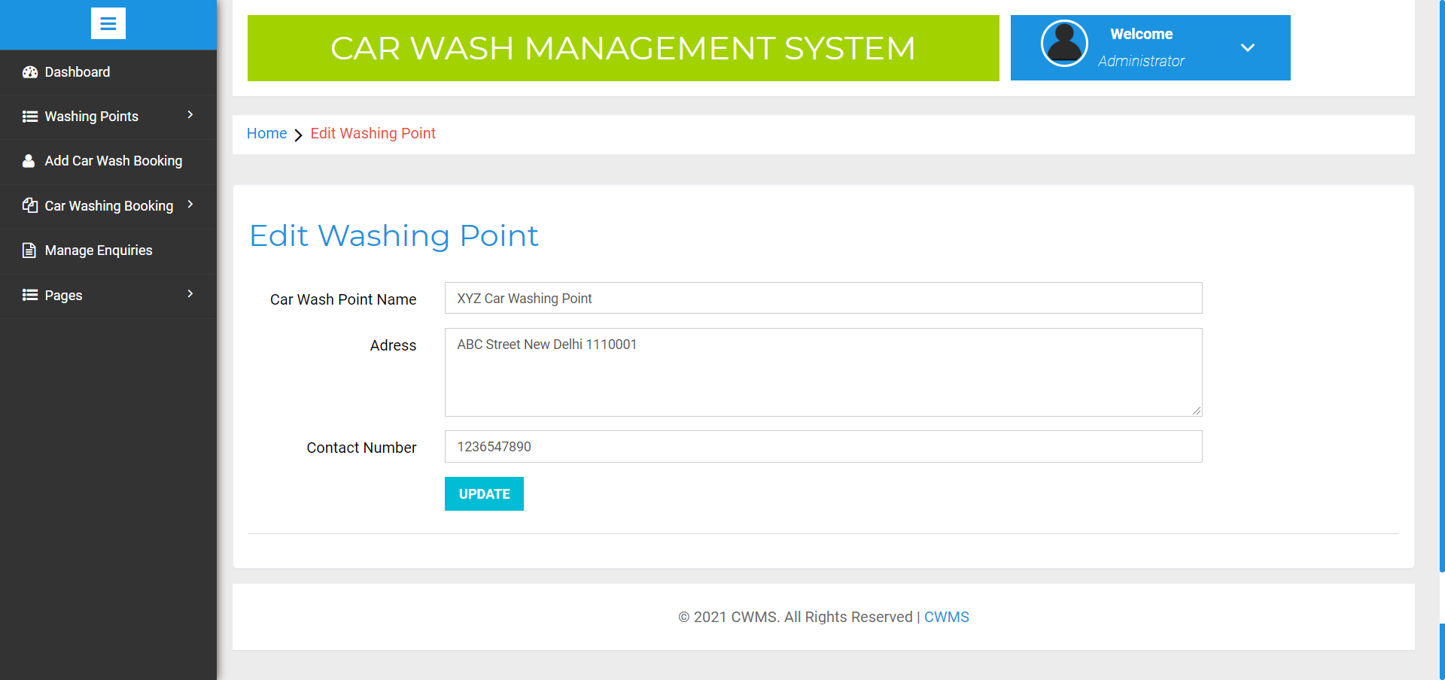

**Add Car Washing Booking**

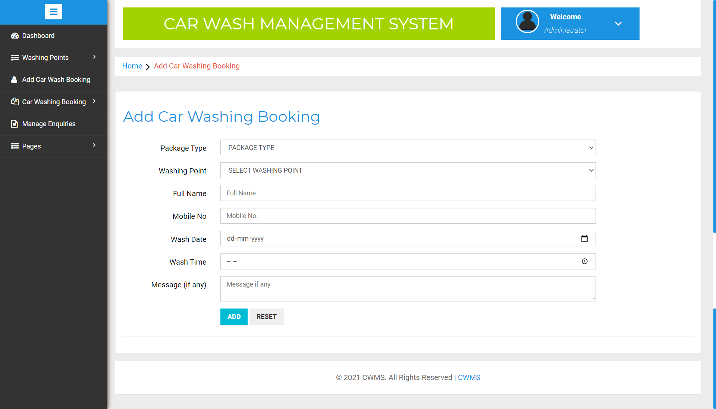

**New Booking**

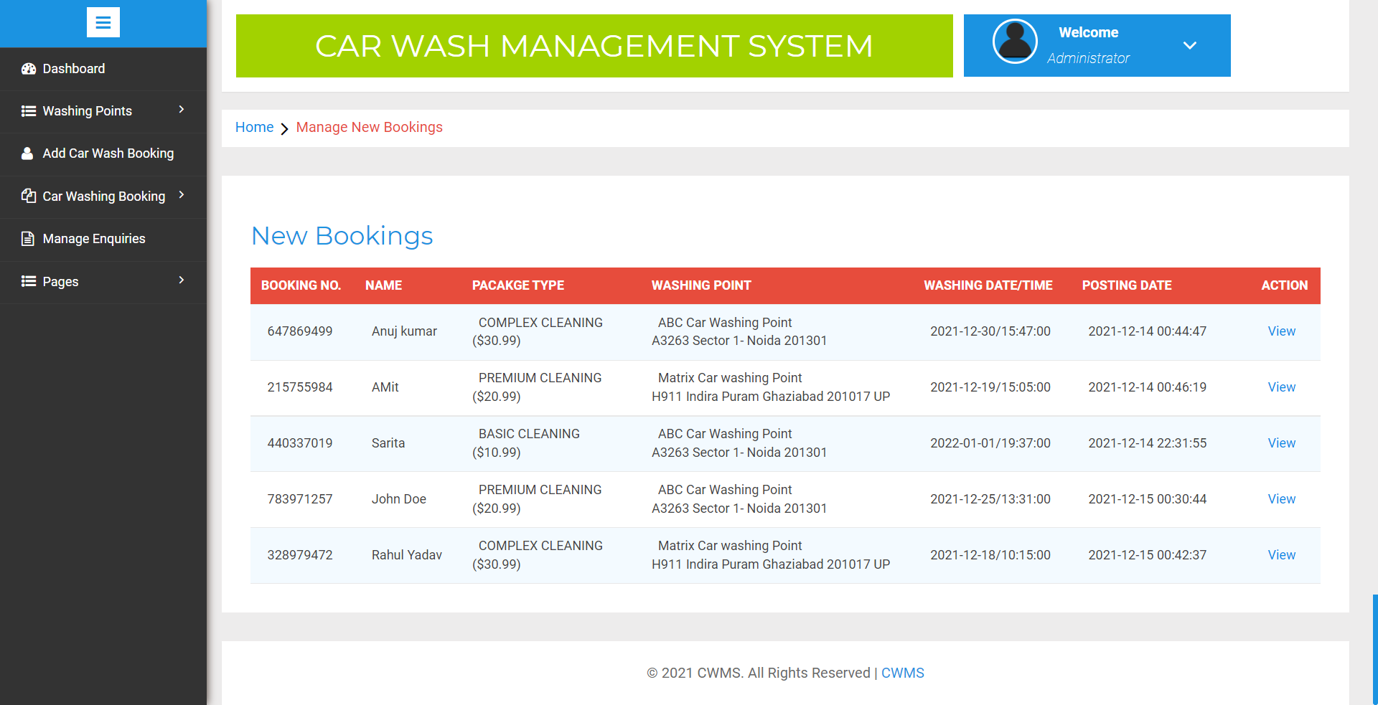

**View New Booking**

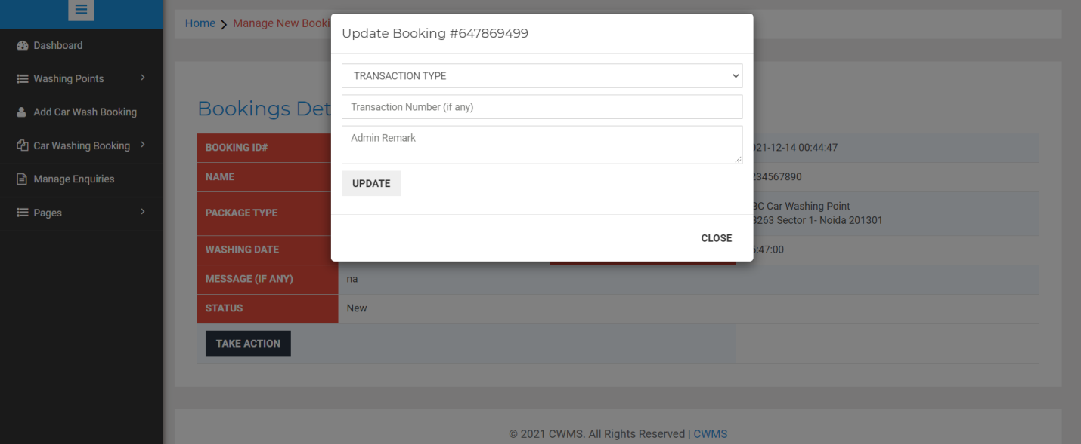

**Completed Booking**

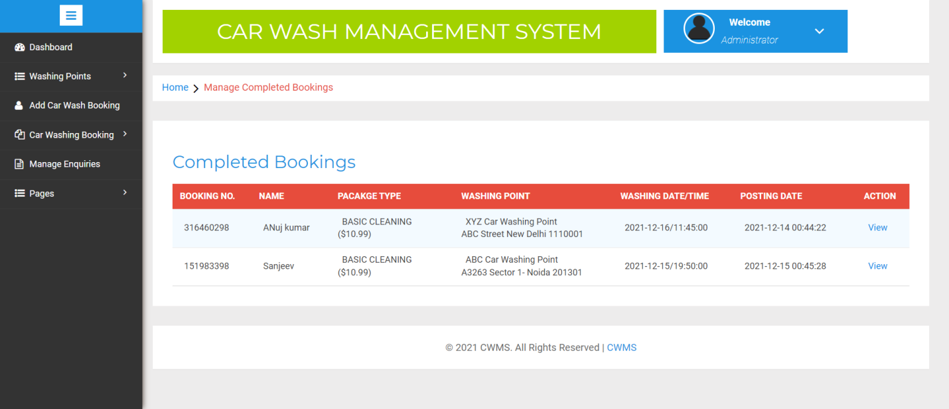

**View Completed Booking**

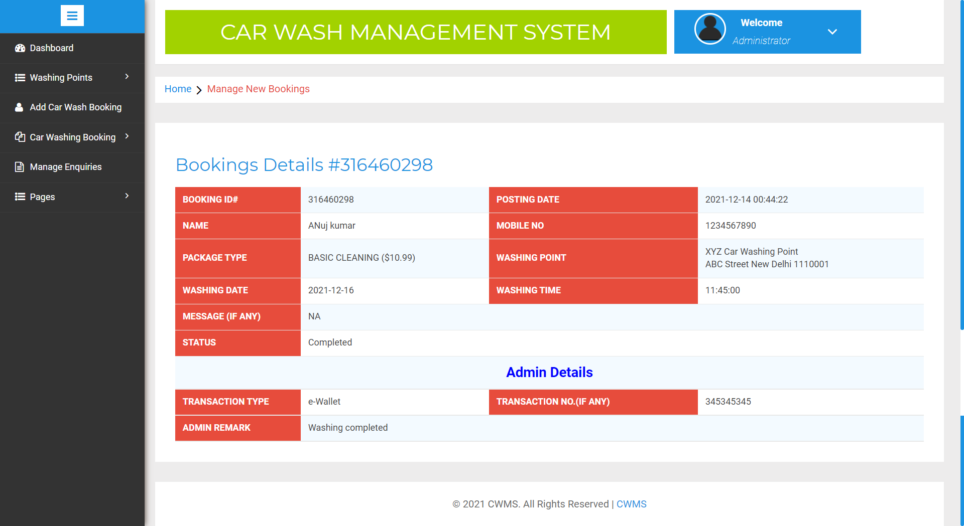

**All Booking**

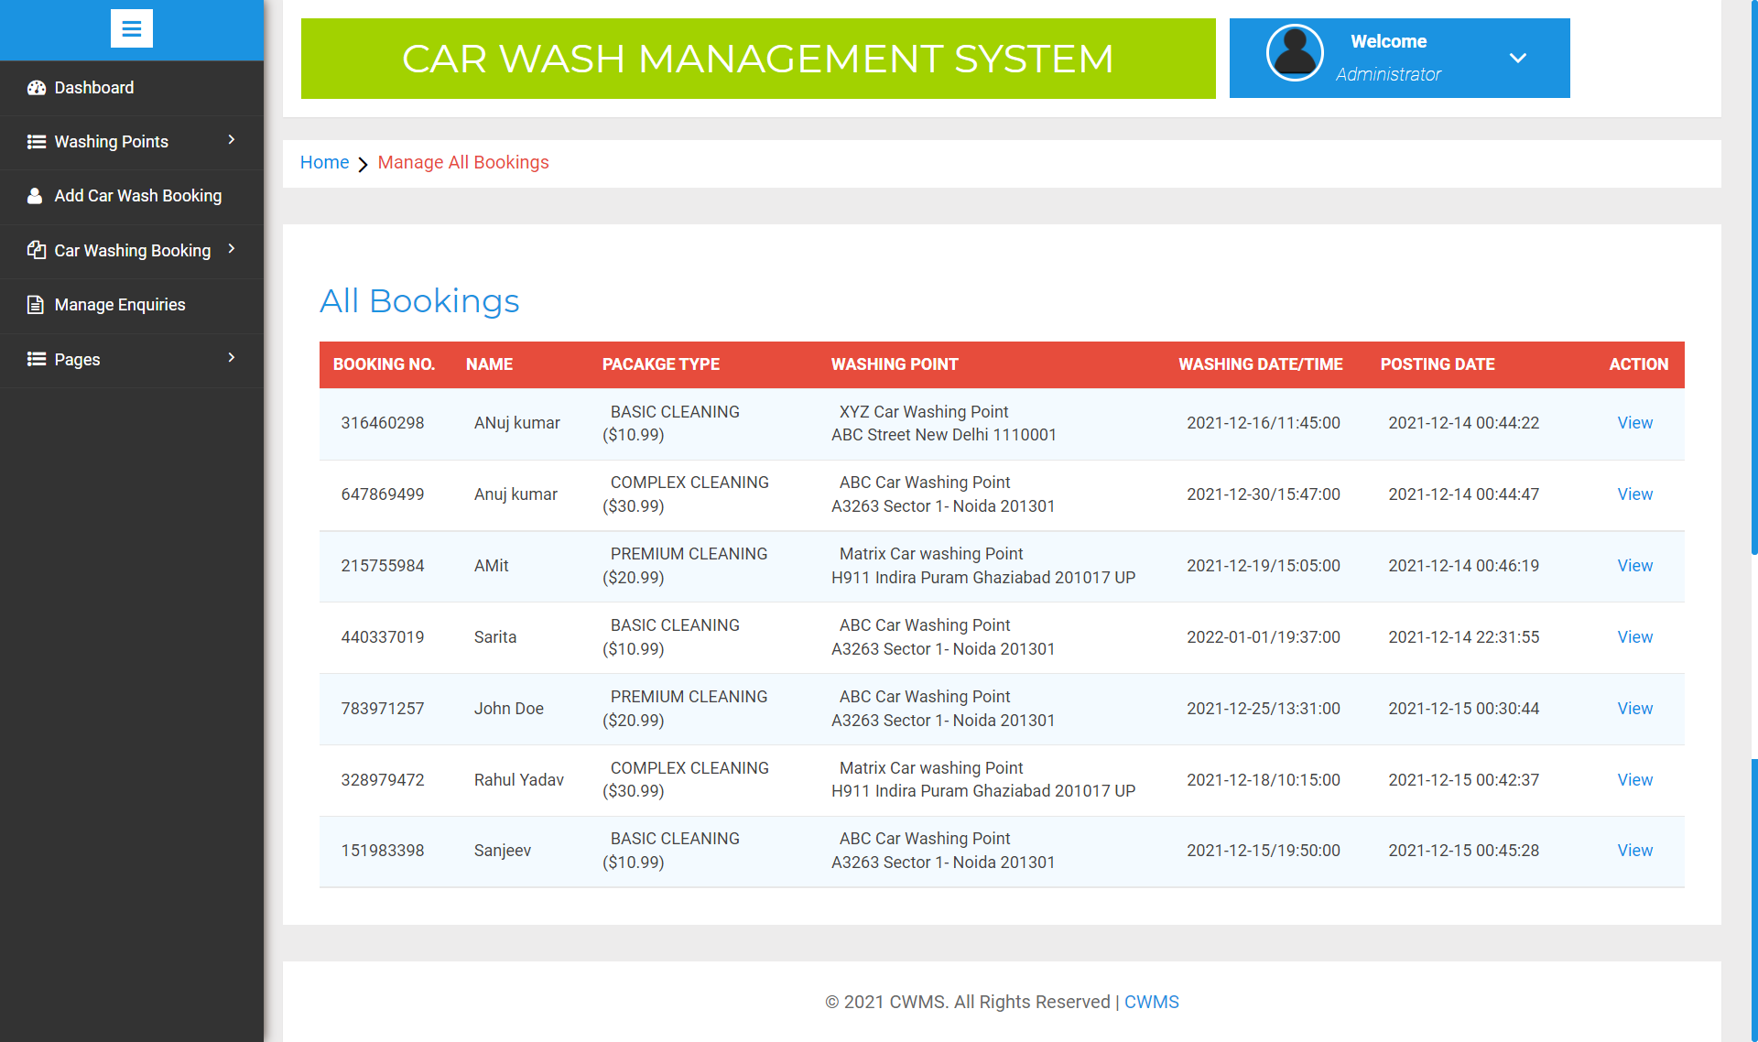

**Manage Enquiry**

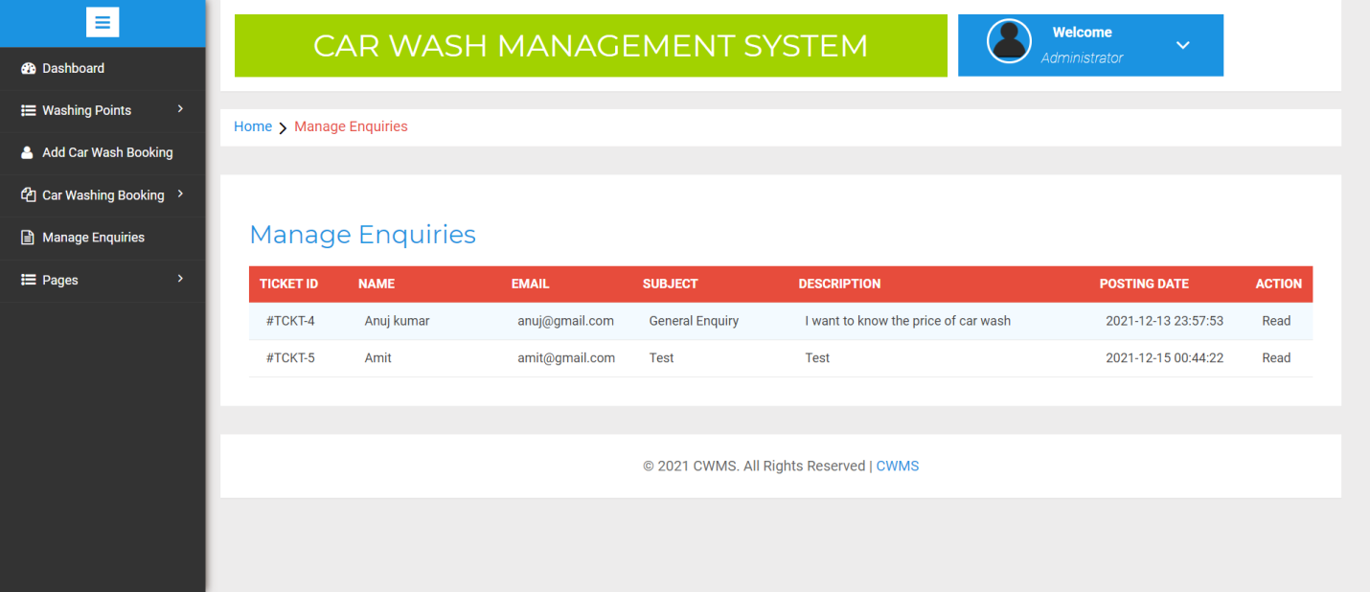

**Update Page Data**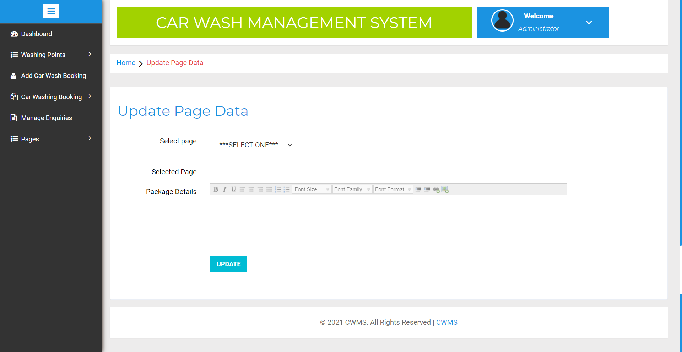

**Update Contact Us Information**

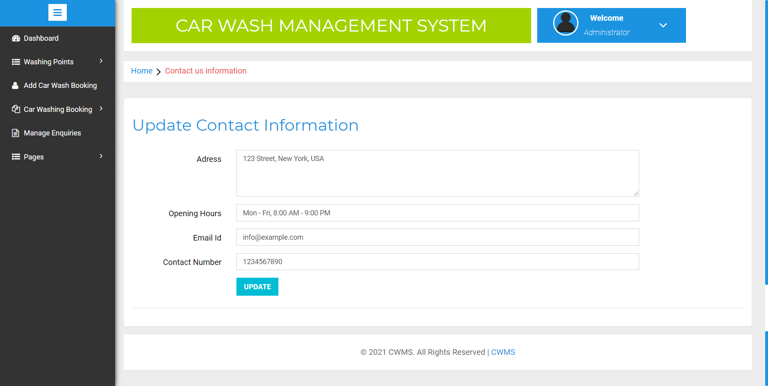

**9. Conclusion**

The project titled as “**Car Washing Management System”** was deeply studied and analyzed to design the code and implement. It was done under the guidance of the experienced project guide. All the current requirements and possibilities have been taken care during the project time.

**Car Washing Management System** is used for maintain the car washing booking systems. This web application will help to perform car washing results in high quality end product. Thus it will be User-friendly and capable to wash multiple cars at a time.

**10.Bibliography**

For PHP

<https://www.w3schools.com/php/default.asp>

<https://www.sitepoint.com/php/>

<https://www.php.net/>

For MySQL

<https://www.mysql.com/>

[http://www.mysqltutorial.org](http://www.mysqltutorial.org/)

For XAMPP

<https://www.apachefriends.org/download.html>